* **What is testing**

Testing is a process of executing a program with the intent of finding an error

* **What are phases are available in SDLC?**

SDLC- Software Development Life Cycle is a process used by software industry to design develop and test high quality software. To develop and deliver any project or product. SDLC process will be followed it contains the below phases.

* Requirement phase
* Analysis phase
* Design phase
* Coding implementation phase
* Testing phase
* Delivery & maintenance phase
* **What is the difference between bug, defect and error?**

Bug: deviation from the expected result, it means a gault in a program which cause the program to perform in an unanticipated manner is called bug

Error: Error will be generated because of wrong login, loop or due to syntax error. Error means to change the functionality of program

Defect: If software misses some feature or functions from their requirements, it’s called defect

* **What is agile process?**

Agile software development is a group of software development methods in which requirements and solutions evolve through collaboration between self-organizing cross functional teams. It promotes adaptive planning evolutionary development early delivery continuous improvement and encourages rapid and flexible response to change

* **What is retesting and regression testing?**

Regression testing is the process of testing already tested functionalities of the iterative builds

Executing the passed test cases on the incremental or iterative builds is also known as Regression testing

Retesting is to test same functionalities again and again by using multiple sets of test data

For e.g.: testing Gmail functionality by using 100 login credentials

Execution the failed test cases of the incremental or iterative build is also known as Restesting

* **What is smoke testing?**

Testing initial build to check stability of software to be tested further is called smoke testing?

What is load performance and stress testing?

Load testing load is number of users the process of increasing the load for the application is known as load testing. Performance testing is the process of checking whether the application is maintaining the targeted response time form the specific load. Stress testing while increasing the load the performance engineer will check the response time fo the application.

* **What is usability testing**

Usability means user friendliness. Test engineer that to check whether the application is maintaining user friendliness with end user or not.

* **What is UAT?**

UAT stand for user acceptance testing and also known as client acceptance testing

Once the application is stable cline will provide UA test case to the testing team. The test engineer has to execute all the test cases. If all the test cases are passed then the client will accept the build or the build will be delivering to the client

Alpha testing: UA test cases will be executed in client’s environment by testing team or Clients team.

* **What ECP and BVA? What are test design techniques?**

ECPS stand for Equivalence class partition ECP technique is used in scenarios where it is not possible to develop the test cases.

With all positive and negative flows. Then will user ECP as below

Dive the test data equally into valid and invalid.

Test the application with valid data so that the filed should accept it

Test the application with invalided data where the field should not accept

BVA stands for boundary valid analysis

This is technique is used where we are planning to test the rang like 0-100 or 0-100 or 1 million to 2 million etc.

As it very difficult to test the application or field with all the values and even to write the test cases for all the positive and negative flows.

In this situation test the application with min, min+1, middle, max+1 and max values. If the field accepting then we conclude that the filed is accepting the range

Test the file with min-1 and max+1 values. If the filed is not accepting then we can conclude that it is accepting only the range.

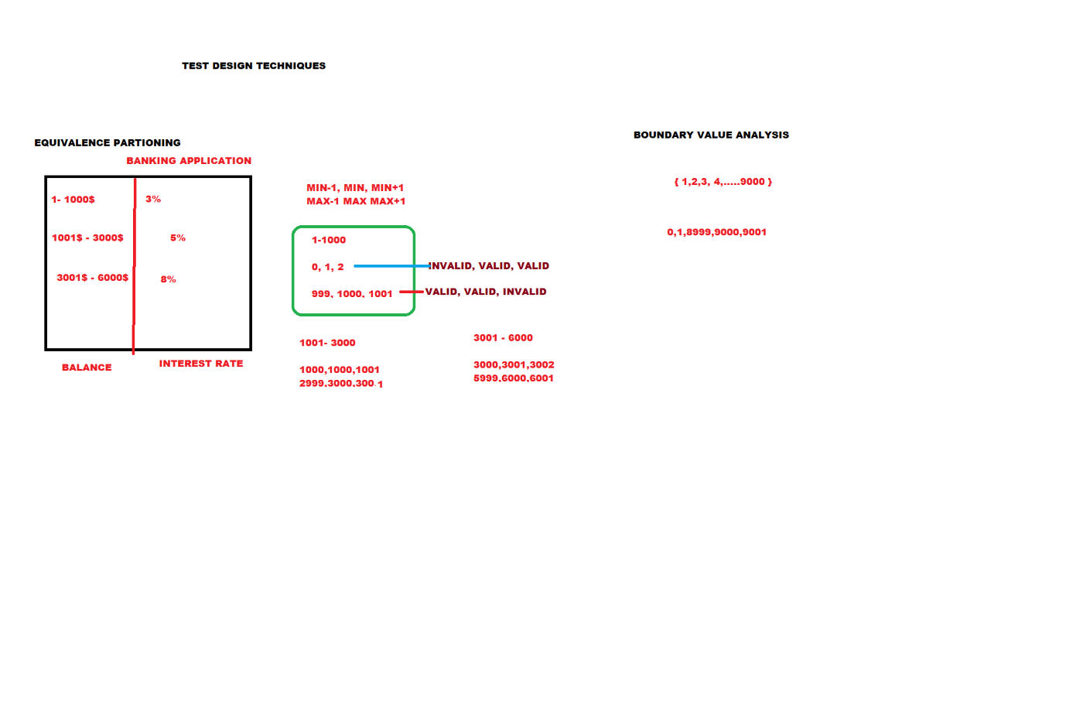

* **What is system testing?**

System testing is also known as nonfunctional testing and is performed on the entire system. Its is to ensure whether the application is maintaining the response time when the maximum and minimum users are working on the application. response time is the time taken between the request and response.

* **What are the differences between web application testing and client server application testing?**

In client server testing there are two different components to test

Application is loaded on server machine and the application exe on every client machine

Testing is done broadly in categories like GUI on both sides, functionality, load client server interaction and backend testing. Most of the client server applications are intranet networks. Web application testing is complex to test as tester doesn’t have control over the application. Application is loaded on the server whose location may not be know and no exe is installed on the client machine. Hence, we applications are supposed to test on different browsers and OS platforms. Its sis tested mainly for browser and OS compatibility, error handling, static pages, backend testing and load testing

* **Explain integration testing and Regression testing**

Integration means combing. Once all the modules are developed by the developers the developer will combine all the modules in a hierarchical order know as integration. Integration testing mean whether the data flow between once module or other is navigating properly or not.

Regression testing is the process of testing already tested functionality on the iterative and incremental builds.

Executing the passed test cases on eh incremental or iterative builds is also known as Regression testing

Explain the difference between test scenario and test case

Test case consists of set of input values, pre-condition expected results and post condition developed over certain test condition

Test Scenario means flow or story. Requirements will be divided into multiple scenarios to test in all possible flow. In short test scenarios is what to be tested and test case is how to be tested.

* **In defects in the software how are priority and severity defined?**

Severity describes how seriously the bug is impacting the application. Each and every bug will have the severity. Severity has below types

1. Blocker

2.very high

3. High

4. Medium

5. Low

Priority describes the order to fix the bugs its of type P1, P2, P3, P4, P5

P1 bugs are fixed initially then P2, P3, P4, P5

We will maintain the priority for each bug based on severity

* **What is the difference between priority in test case and priority in bugs?**

Priority in test cases: every test case /scenario has a priority it describes the importance of the test case. There are 54 types of priorities.

P1- the test case describes about the main functionality

P2- the test case describes about the field level

P3 – All the GUIs

P4 if the test engineer is planning to provided any suggestion to the application, then he can write test cases where the priority is P4

Priority in Bugs: Base on the severity the priority will be assigned.

Priority describes in which order the has to be fixed by developer Blocker -P1

Very high-P2

High-P3

Medium -P4

Low -P5

* **What to you write in a test plan?**

Plan is strategic document which describes how to perform one task in an effective and efficient manner. Software test plan is a strategic document which describe how to perform testing in an effective and efficient manner. It will be prepared by the test lead

* **What is AUT?**

AUT stand for application under test. The project which is undergoing testing is known as AUT

* **What is Adhoc testing**

After understanding all the requirements of the application and one round of manual testing is completed then test engineer will perform testing in user defined order is known as adhoc testing. By performing adhoc testing the test engineer can provided the user friendliness to the application

* **What is alpha testing and beta testing?**

Alpha testing: UA Test cases will be executed in test environment by test team

Beta Testing: UA test cases will be executed in client’s environment by testing team or client team

* **What is compatibility testing?**

Testing the application in multiple browsers and operating systems(environments) and check whether the application nis working as expected in all the environments or not is known as compatibility test

Eg: test the Gmail.com Firefox, IE, google chrome, safari and opera in windows ,Linux and mac systems

The kind of testing is useful for internet-based application’s like seleniumtesting.com. Facebook etc.

* **What is end to end testing?**

Scenarios means the flow test engineer has to identify the end user used scenarios in the application. The test engineer has to execute all the end user used scenarios and checks that whether the applicants fulfilling the end user’s requirements or not is known as end-to-end testing.

* **What is localization testing?**

Test engineer will test the application in all the local languages like Hindi, Bengali, Uganda etc. an check that whether the application is working as expected or not is know as localization Testing. Localization testing supports maximum of 10 languages. hence, we call is as L10 N testing

* **What is internationalization testing?**

Test engineer will test the application in all the international languages like French Chinese Japanese etc. is known as internationalization test. It supports 19 languages hence will call it has I18N testing

Eg: test Gmail..com in all the internationalization languages

* **what is monkey testing?**

Monkey testing means testing the application by performing abnormal actions like:

Continuously click on any field for longer period of time and check that whether the application is throwing any error or not

Enter the invalid data like tags in the application and check that where the application is crashing or not

* **Explain the bug which is high severity and low priority**

High severe bugs will e having high priority. But if bug is not related to the current release, then priority of the of bug will became low priority. the development lead will have the permission to change the priority

Explain the bug which is low severity and high priority

Low severe bugs will be having low priority but if the bug is related to ethe current release then the priority for bug will became high priority the development lead will have the permission to change the priority

* **What is endurance testing or soak testing?**

Test the application with minimum load for 1 to 2 hours and check that whether the application is aminating the targeted response time or not is known as soak testing

* **What is volume testing?**

Testing the application with maximum load for 1 to 2 hours and check that where the application is maintaining the targeted response time or not is known as volume testing.

* **Difference between verification and validation**
* **Explain defect life cycle**
* **What is RTM or how do you ensure all requirements is tested?**
* **Explain STLC**